The Sunflower story. Part 1
This is a personal story I like to share with you for various reasons. First it is a lovely story of hope. Then it is about the spirit who always finds a way to leave us these messages in the most wondrous ways. Last it is a tribute to the makers of the movie Patch Adams and of course to Robin Williams who now lives on in Spirit until he will be reborn and I am sure he will play a joke or two to his loved ones if he gets the opportunity.
It is story about not having to believe anything and about coincidence which I firmly believe does not exist! Everything has got its reason and is perfect as it is.
Even now writing this story I find amazing facts that I did not know of before and I am hoping that by sharing my” awakening” moments it might help you to trust in the wheel of life and to help you in time of doubts and for you to know that never we will have to walk alone on the challenging path of life here on earth.
Yes we are here to learn, to become wise of course and to do the best we can so we can say goodbye to everyone with a peaceful heart and knowing that we were guided all the way and we only had to listen and look for the signs and messages in a different way than we may have thought.
Yes like the butterfly in the movie Patch Adams. Just google the title and it is a movie made in 1998.Watch it if you have not yet seen it. It is very emotional but beautiful and that is where I first learned about the messages we receive or can receive if we are open to it.
When my oldest daughter was 3 years old, my mother was dying of cancer. We happened (?!) to be in Holland and had planned a nice long holiday of 9 weeks. I had no idea at that stage that we were going to have to say goodbye to her and farewell her forever. When we arrived I found everything that I could wish for and what I like in the apartment where we were to stay for 9 weeks. I asked my mum why she was spoiling me this much and she said I deserved it. Of course every daughter deserves everything a mother can give to her but it felt as if there was something she was not telling me. I asked how she was feeling and she said oh so fine, don`t you worry about me. Everything is all right my kiepela (her nickname for me). The previous year she underwent an operation to her bladder and kidney and was found to have cancer but all the check-ups were clear so there was nothing to worry about she said. She had finally given up her nasty habit of drinking and lived with her partner, playing scrabble almost every night. Enjoying music especially choir music and socialising with friends and doing a lot of laughing!!
The weather was perfect, the green grass smelled the best I could remember and brought back lovely memories of my own childhood and we tried to enjoy every second of the day with all the Dutch things like cycling, eating that special sausage and trying a different dessert every night. Oh, don`t forget buying and sampling the best ice-cream of course. The first 4 weeks were total bliss and we were not prepared for that terrible news when we found her covered in sweat and hardly able to understand what she was saying. She was delirious from the fever and when the doctor got called he decided to admit her to hospital to see if there was any way to make her feel a bit better before she would die. He thought I knew that she was not well and that she most likely had metastases of the cancer in her liver. She just had a biopsy done the last week(which she had not told me) and the fever was the result from that.
Clearly she had not told me anything at all about her diagnosis and she knew she was dying but wanted for me to enjoy the time in Holland as if I was on holidays and of course how noble is that ?!
After that only about 10 days were left of her life and after a brief hospital visit she wanted to go home and die there. In Holland the palliative care service is well arranged and a few funny things colours this otherwise straight forward story.
She was adamant she was going to go home on that same day she decided this and everyone had to help out. We all know that when you want to leave hospital it is a bureaucracy to get things quickly and it usually takes a few days to organise the practical side of care at home.
Not with my mother in charge, she would go despite the fact that things were not in place but her brother Theo made sure there was a bed delivered that same day and my father( My parents were divorced and not in contact anymore) who suffered from motor neurone disease was kind enough to lend a bedpan and a few other gadgets he did not use as yet because his illness progressed only slowly. Yes he still loved her enough to be kind to her in her last days even though they were not on speaking terms. Thanks very much Dad, I am sure you passed the test of being good and no questions asked when judgement day was there for you. RIP 2001
All good and well, I hear you thinking when will I hear about the sunflower. Ok right now.
On the last day she was well enough to sit outside in the garden and enjoy that little bit of sunshine, her partner and my mother had planned for my 3 year old to plant some sunflower seeds in the garden. She would take them from my mother’s hand and put them in the soil as to symbolise that young takes care in to continuing life and to make sure growth will take place. So they say.
The first year the Sunflowers did not grow. I got pregnant but had a miscarriage. The following year however the sunflowers were blooming and very tall and this is where my second daughter was born and of course the symbol of sunflower represents my mother and where ever I go in the world and when I see sunflowers I know she is there with me. 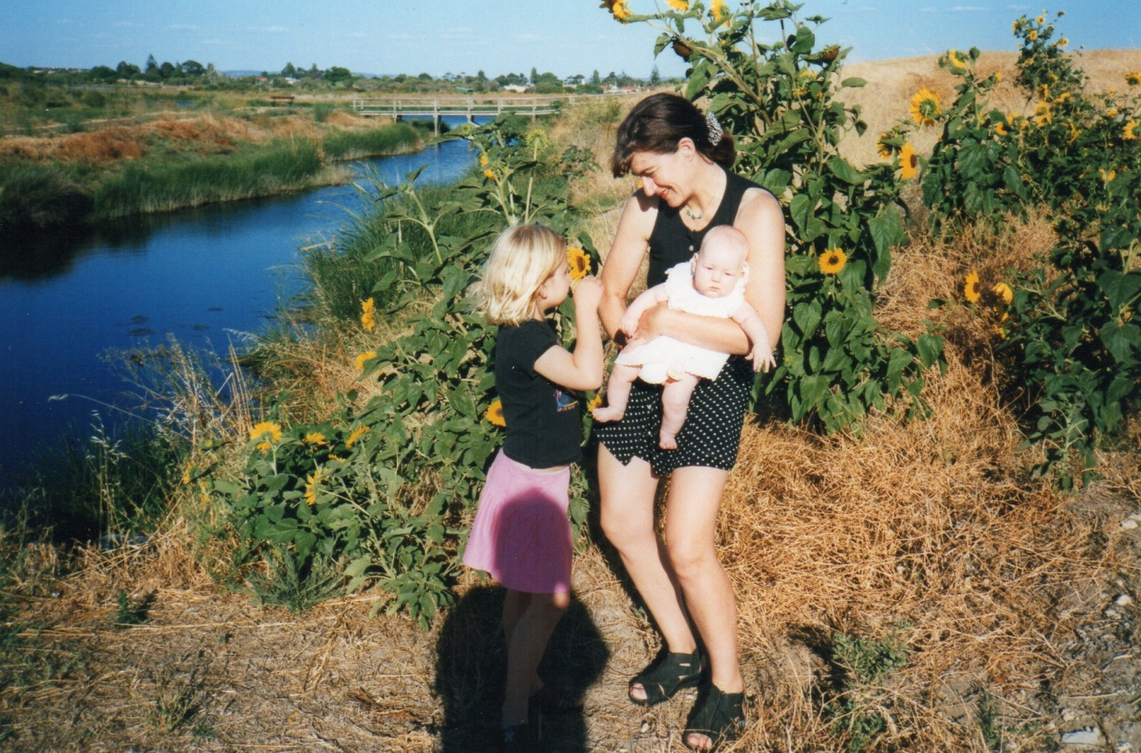

Here we are, my 2 beautiful girls Shirley and Cynthia and me.
I am going to write more over the next few days and tell you about these other messages regarding the sunflower and also about the Owl and the butterfly. Let me know if you would like to hear that too.
Much love from Monique.

