Sunflower story part 3 The Owl
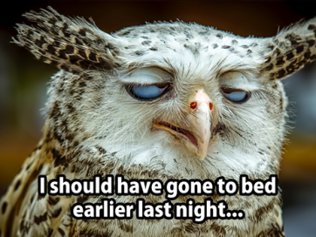
I probably should not have started this story at this time of the night, but I have an overwhelming feeling of not achieving what I really would like if I don`t do it now. Of course, I don`t want to listen to my wise part of my brain that says leave it and just have your shower and relax for once.
The good thing living now and not 100 years ago is that we have computers and that you can save your work and re write it however many times you like. So, it may be wise to make a start otherwise you are never going to get part 3!
So far, everyone liked what I wanted to share with you and of course that pleases me and polishes my ego which wisdom tells me not wisdom but Eckhart Tolle (author of the power of now) told me it is the ego that I really should try to lose to bring me long lasting happiness!
You recognise that discussion with yourself? We all want to be wise, but we don`t listen at the best of times to what it says inside of us. The quiet within, the silence, the darkness that can turn into light instantly if you lit it with your belief and trust.
To me getting this story of the owl is a perfect example of believing and trusting what is on your way and that you will be supported all the time, although it is not transparent and for everyone in the world to see. It is what and how you see the world what makes you see things the way you do.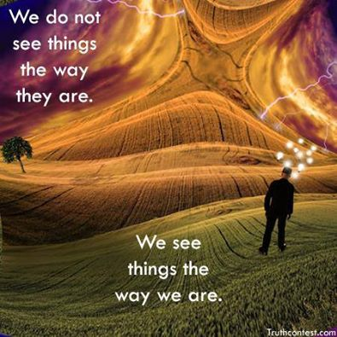
It was 2011 going onto 2012 and in all the 9 years we lived in Bunbury near the Sea, had we not seen an owl or heard an owl. But there it was, tiny, yet impressive by its shape and looks and just sitting on the grass verge opposite our house. The headlights were shining in its little face and it stared back at us as we were staring at this gorgeous creature the magnificent Owl!
Unsure about why we saw this I felt it was a sign. To me the owl represents wisdom but when you google it you find it can also be a bad omen. I will tell you more about this later.
We left it for what it was at that time but a few weeks later I was doodling at a meeting and to my surprise an owl came out. I have never been able to draw nicely and never ever attempted a drawing of an owl. Yet it was there on paper. Not just once but a few times this kept coming in my little scribbles. (Doodling is scribbling things on paper, you just do this when you are a bit bored and most of the time my doodling is looking like flowers or heart shapes or trees).
I just tried to draw another owl now and I cannot do it! How weird is that. Has any one of you experienced something like this?? I am wondering what you are drawing when you are scribbling, please let me know.
For those of you who know us will also know our story of how my daughter was battling with an illness in this period of time and that we had to find the wisdom and the courage and all the believe that we could make it through to what became an experience in life that completely changed our views of the world and the people around us!

Coming back to the owl and saying it can be a bad omen, a little correction is in place. In certain cultures (China Egypt, India) the owl is associated with death but not in the symbol of death but as a guardian of the afterlife. It is there for taken as a warning.
The native Indians view the Owl as their protector and will wear the feathers to ward of bad spirits (No I have not done that yet!! Ha ha)
The following qualities are associated with the Owl.
Intelligence, Brilliance, Perspective, Intuition (inner knowing, psychic ability), Independence, Wisdom, protection, mystery and POWER.
We all have the power to make changes, to learn, to cultivate our wisdom by looking in the mirror and change ourselves and become whoever we want to. We also have a choice in how quickly we judge and say something that might be hurtful not just in the short term but also in the long term.
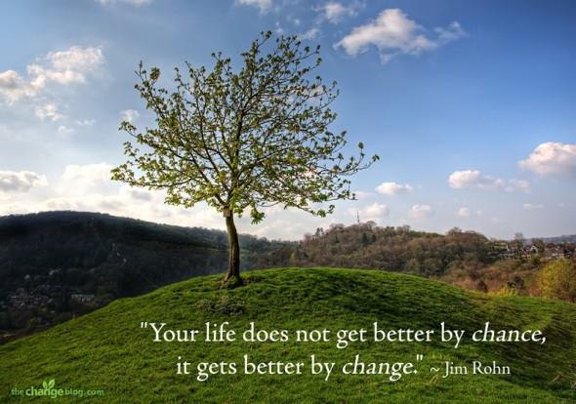
For us as a family we have been blessed to experience the kindness and support of most family and friends throughout this challenging period in our lives. Also all the professional help we received made us realise how we need each other and that simply nothing can be done just on your own.
Teamwork, listening, learning and growing are keywords in the healing process.
Respect for people’s opinion and understanding where they are coming from and how they view the world from what they know was what we learned. I will not say that we have developed all qualities yet that are associated with the Owl (I wish😉) but it was certainly an opportunity to read up and find out about suffering in life and how you find out which people are on your side and have got wisdom and patience developed already!
I know that this period of my life surely made me grow! Now writing this story able to reflect on what hopefully will be the past and not to be repeated any time soon and having Learned to trust and follow the lead of the signs and symbols through stories like this, may offer hope and give you some tools to use if and when you are going through tough times or know someone else who you would like to help.
One other thing I like to share is that there is always someone that is worse off than you. Each one has stories to tell. Knock on someone’s door and listen. I am saying this in a nice way. It opened my eyes when someone suggested this to me.
For me personally it now is butterfly time but that is another story. Want to hear that one? You know the drill, just say yes, I want to read more or no thanks. No ill feelings.
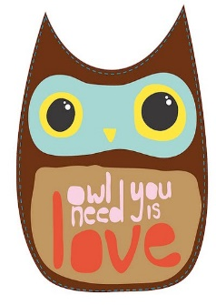
This Photo by Unknown Author is licensed under CC BY-SA-NC
Much love from Monique.

